horizontal line

**Delhi Technological University**

Department of Applied Physics

IVth Semester

**MICROPROCESSORS & INTERFACING**

**MPI EP - 206**

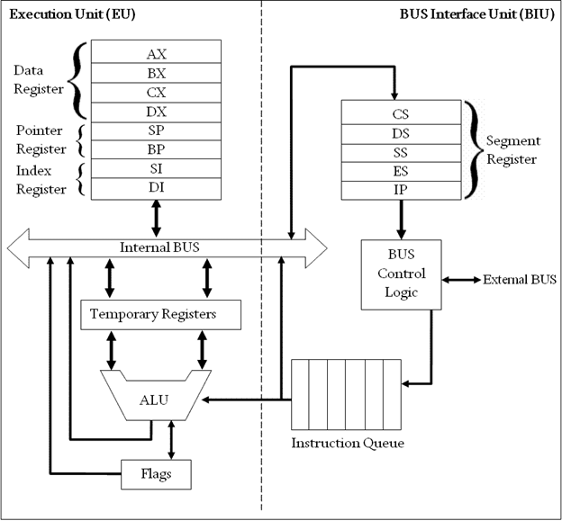

# **Submitted by :**

**ADITYA SINGH, 2K19/EP/005**

**Submitted to:**

**Dr. Rishu Chaujar**

# **Experiment 4**

**Generate Fibonacci Series Less than FF**

**THEORY**

1. org 100h is used to set IP to 100h
2. Store 0 to AX register (1st term of fibonacci series) and 1 to BX register (2nd term of fibonacci series) .
3. Iterate 6 times to get the last term less than FF so CX=6.
4. Fibo: (Label)
5. Add contents of AX and BX and store the sum in AX (AX has the next term of the series).
6. Add Contents of BX and AX and store the sum in BX (BX has the next term of the series).
7. Repeat steps 4-6 until CX=0.
8. At the end of the loop , the second last term is stored in the AX register and last term is stored in the BX register.

**CODE**

**org 100h**

**mov ax, 0**

**mov bx, 1**

**mov cx, 6**

**fibo:**

**add ax, bx**

**add bx, ax**

**loop fibo**

**ret**

**OUTPUT**

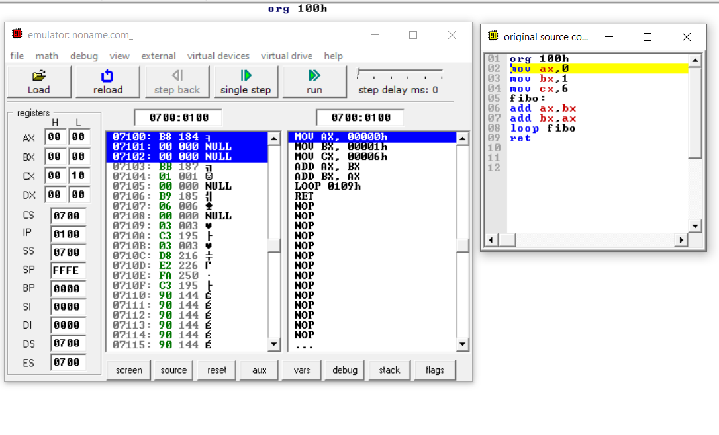

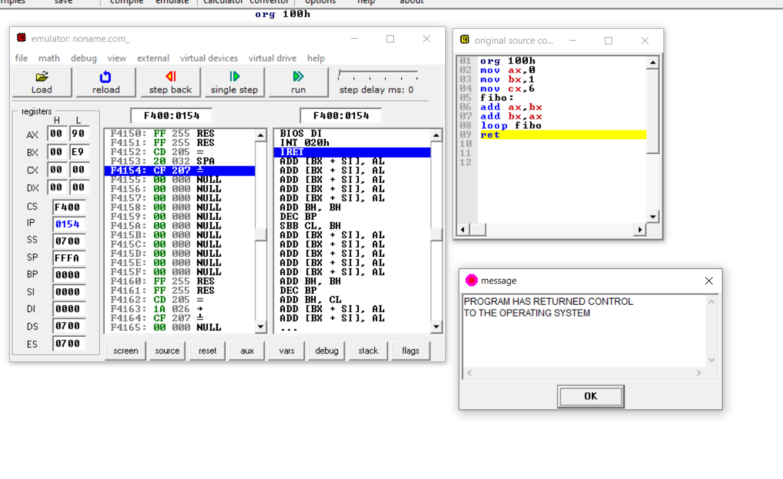

**END**